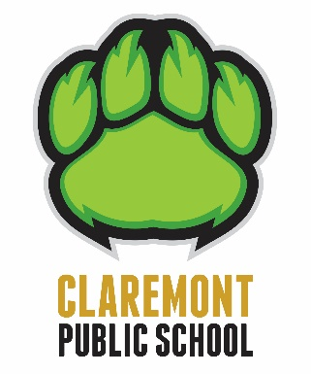
Claremont P.S. Parent Newsletter

October 16, 2020

Halloween

Students from all grades are permitted to wear their costumes to school on Friday October 30, but the costumes must remain on all day and no costume face masks are allowed. We will have a virtual parade inside the classroom shared only within the school. Students may bring a treat for themselves but no sharing of treats, even if they are sealed, is permitted.

Parents may not send any type of food for the class to share.

Covid Student Checklist

We have had some parents question protocol for students who are sick and the criteria for testing. I’m attaching a link to the Student Checklist. https://covid-19.ontario.ca/school-screening The checklist was last updated October 5

Early Childhood Educator Appreciation Day

On October 22 we celebrate and recognize the hard work, meaningful care and continuous learning ECE’s provide children every day. Nicole Siblock plays an exceptional role as an educator in our JK/SK classroom. I’m sure that the entire Claremont community joins with the school staff in thanking Nicole for all of her efforts in supporting our students.

