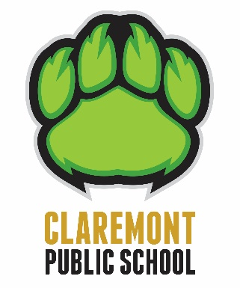
Claremont P.S. Parent Newsletter

November 1, 2020

November 2 - 6

In 2016, Ontario passed legislation declaring the first week of November Treaties Recognition Week. We are using a wide variety of resources to encourage respect, gratitude and appreciation for the indigenous people who have inhabited and continue to live on the land we share. Students will learn about what treaties are and why they matter to all Ontarians.

Clothing
The weather is starting to be unpredictable. Mitts, gloves, toques and heavier coats are making an appearance and students are juggling a mask with them so it’s understandable how items are dropped. It would be very helpful if student belongings were labelled with their name so lost items can be returned to their owner

Terry Fox

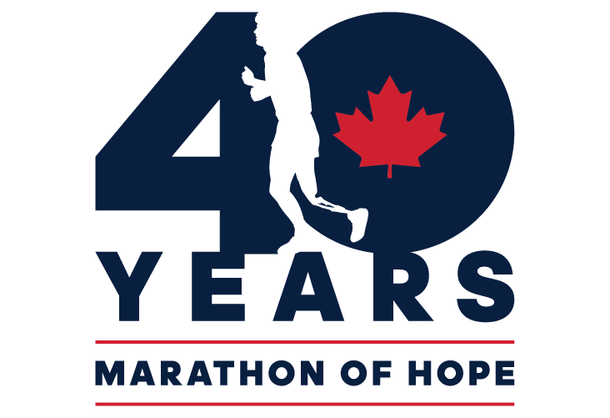
Congratulations Claremont Public School! Our school did a tremendous job fundraising for the Terry Fox Foundation through our school's Terry Fox Run this year, raising a total of $1870! This surpasses many of our previous year's totals which is remarkable considering the challenges we faced in preparing for and completing this year's run. Thank you for all of your support for this worthwhile cause.

Halloween at Claremont

Most students came to school in costume on Friday. The school held a virtual parade in the afternoon and had some fun activities. Here are a few pictures of the classes.

