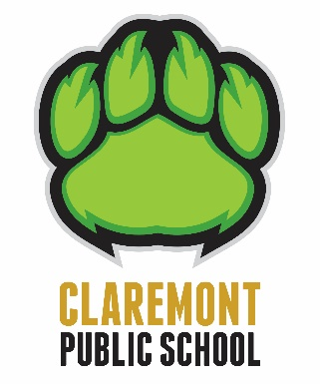
Claremont P.S. Parent Newsletter

October 9, 2020

Supply Principal

My name is Mrs. Morrison and I have the pleasure of being the principal at Claremont until the end of November. I enjoyed the opportunity of meeting many of you as you dropped your children off in the morning or picked them up in the afternoon. If you have any questions or concerns please feel free to contact me by calling the school or sending me an email.

Grade 5/6 Teacher

We welcome a new teacher, Ms. A. Ayub to the 5/6 split. She will be in the role until Mr. Brown returns from his leave sometime later this year.

Halloween
I’m sure that you all have questions about how Halloween will be celebrated this year. We are currently looking at our options, with safety being our biggest priority. Information about our plans will be forthcoming by the end of next week.

Progress Reports

Progress reports will go out November 11 and virtual interviews will be on November 13. Progress reports do not have marks but indicate if a students is progressing well or with difficulty.

Parent Drop Offs
*New*

Parents are requested to wear a mask at all times on school property, even outdoors. We encourage you to promptly leave the school property after dropping off your children in order to maintain safe distancing and safety protocols.

Indoor shoes, heavier coats etc.

With the weather soon to become colder we have assigned students lockers or hooks to store their shoes, coats and backpacks. We are staggering the number of students that are at their lockers/hooks at any given time to maintain a minimum of a 1 metre distance between them.

Students Absences

If a student is absent for more than 5 consecutive days, a “Temporary Excuse of Attendance” form must be filled out. If a student is absent for more than 15 consecutive days, they will be removed from the daily student attendance register.

SCC Virtual Meeting

Our next School Community Council (SCC) meeting will be held virtually on Tuesday October 20 at 6:30 p.m. The new SCC co-chairs are Camilla Arnold and Lisa Fenech.

